The time it takes for me to solve a 7x7x7 Rubik’s cube based on my time on 5x5x5

In order to do this simulation, let’s first take a glance at the general process of how to solve a high-order cube(5x5x5 and up)

1. Reduce the cube into a 3x3x3;
2. Solve it like a 3x3x3.

In this presentation I will not go into detail of how to solve a 3x3x3, since there are tons of methods and the one I use is pretty hard to explain. Therefore, in the simulation, I will just assume that the time it takes me to solve the 3x3 stage is a constant.

Instead, what the simulation is more focused on is the first part, the reduction process. The reduction process can also be broken down into these steps:

1. First four centers;
2. Last two centers;
3. First eight edges;
4. Last four edges

OK… What are centers and what are edges???

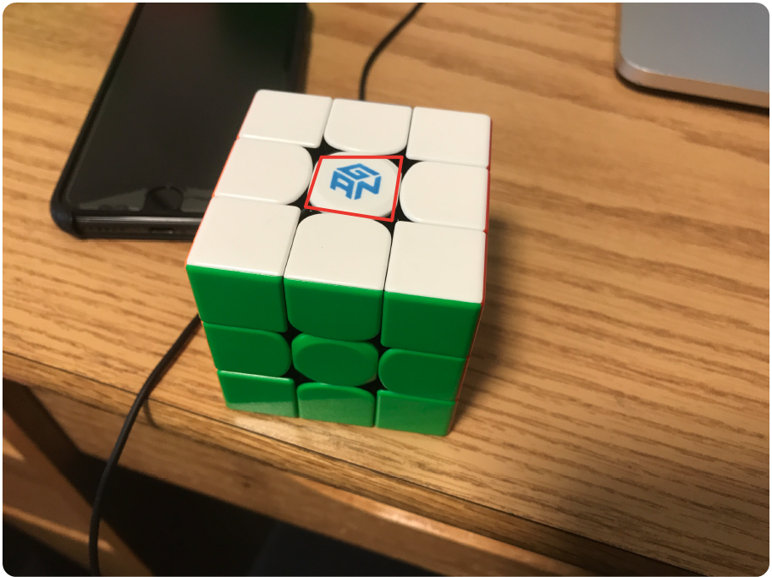Centers are pieces on a cube that only has one color on it, so for example, a center on a 3x3 would look like this:

So that is one center piece. On a 5x5, center pieces look like this:

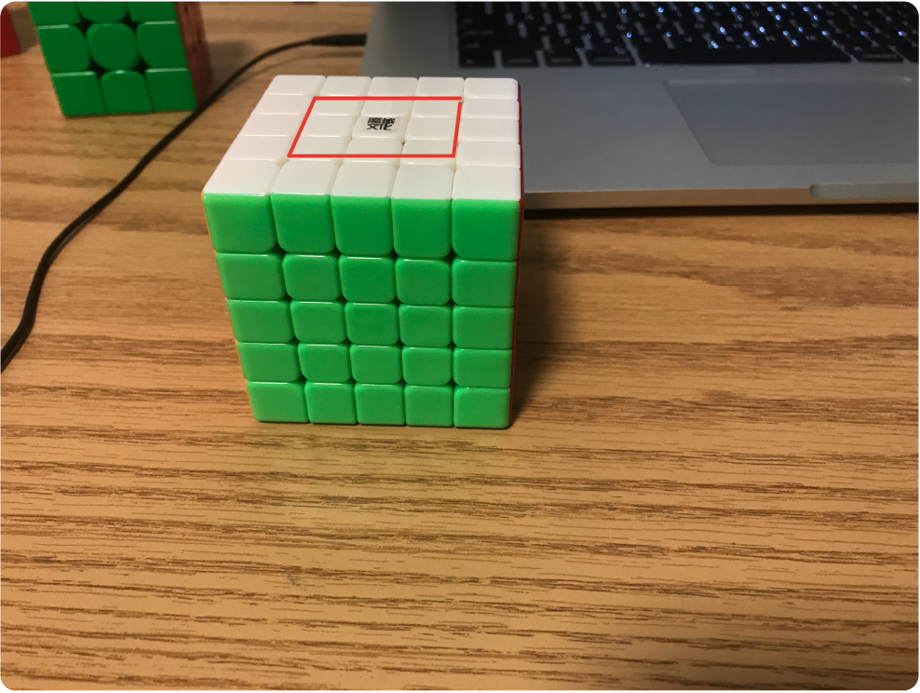

Pieces included in the red polygon are center pieces. As you can see, there are 9 center pieces for a 5x5 on each side.

What is an edge then? An edge is a piece that has two colors on it, as shown in this picture:

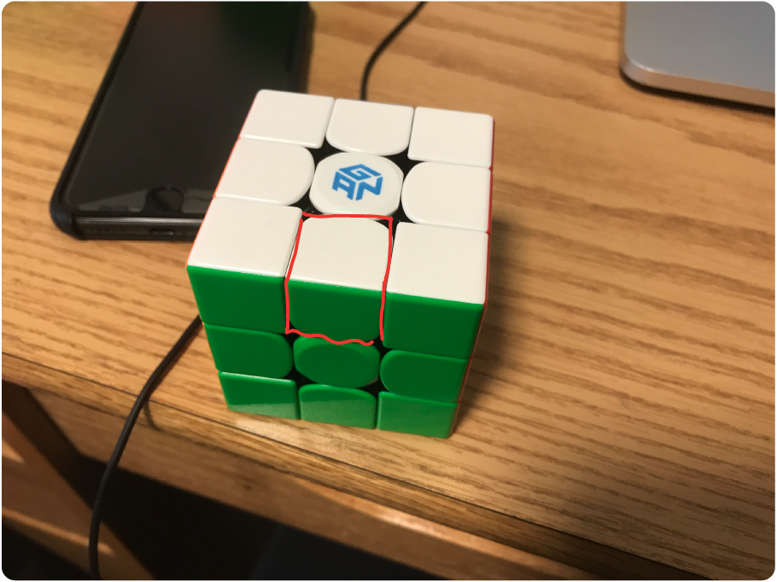

And on a 5x5, edges look like this:

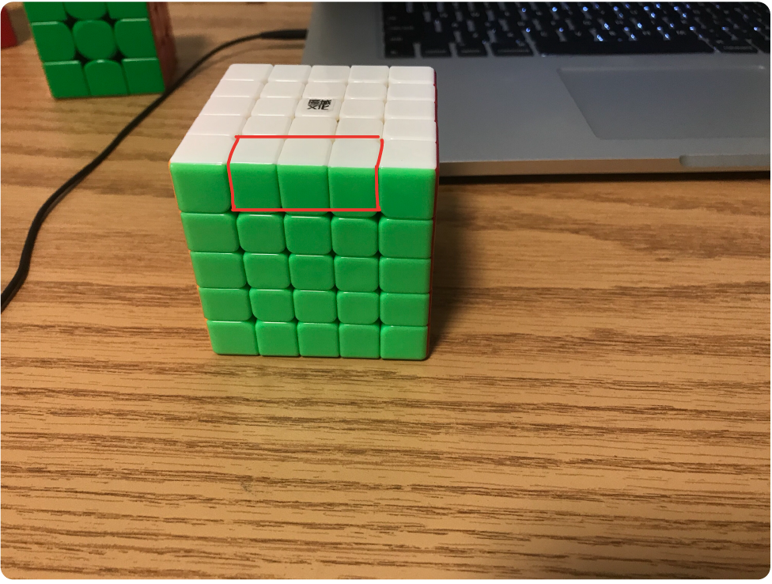

Therefore, the reduction process is basically turning a 5x5 into a 3x3.

But how can you solve a 5x5 like a 3x3?

The answer is to turn outer layers only.

If you treat all the center pieces inside the red polygon in the second image as a single center pieces on a 3x3, and all the edges in the fourth image the same as a single edge pieces in image 4, then the cube can be seen as the same.

In other words, to reduce a big cube is the same as to find centers pieces that have the same color, and put them on one side; find all edge pieces that have the same color and combine them.

So solving the first four centers is to have 4 3x3 centers on a 5x5, and last 2 centers is to solve the remaining two centers. They are separated because the way to solve them are a little bit different. Similarly, the way to pair up the first eight edges is different from the way to pair up the last four edges.

These are times it takes me do each step on a 5x5

for 5x5:

first 4 centers: 35s-60s

last 2 centers: 10s

first 8 edges: 90s-110s

last 4 edges: 20s-60s

3x3 stage:20s-35s

for each piece on the cube:

first 4 centers: lower bound: 35/32 = 1.09s/piece , upper bound: 60/32 = 1.875s/piece

the number is divided by 32 because there are 32 pieces to solve during this stage; there are 9 centers pieces on each side, but the middle center piece never move, so there are only 8 center pieces that need to be solved for each side, and there are 4 sides to solve, so the pieces that I need to solve is 8\*4 = 32

for each bar:

last 2 centers:3.33s/bar

for the last two centers, you build 1x1x3 bars. The time it takes me to solve a bar

for each piece

f8e: 90/8/3=3.75, 110 / 8/3 =4.58

l4e:20-60

3x3:20-35

And then, I just used the data above, and multiplied it by the number of pieces on a 7x7, and wrote my simulation based on that.

on a 7x7:

f4c: 104.64 , 180

l2c:16

f8e:150, 183.2

l4e:40-120

3x3:20-35 45-60(This is the actual time it takes for me to finish this step)

There are 4 random variables, so it took a long time to run this… First I ran 100 trials, and the graph looks like this:

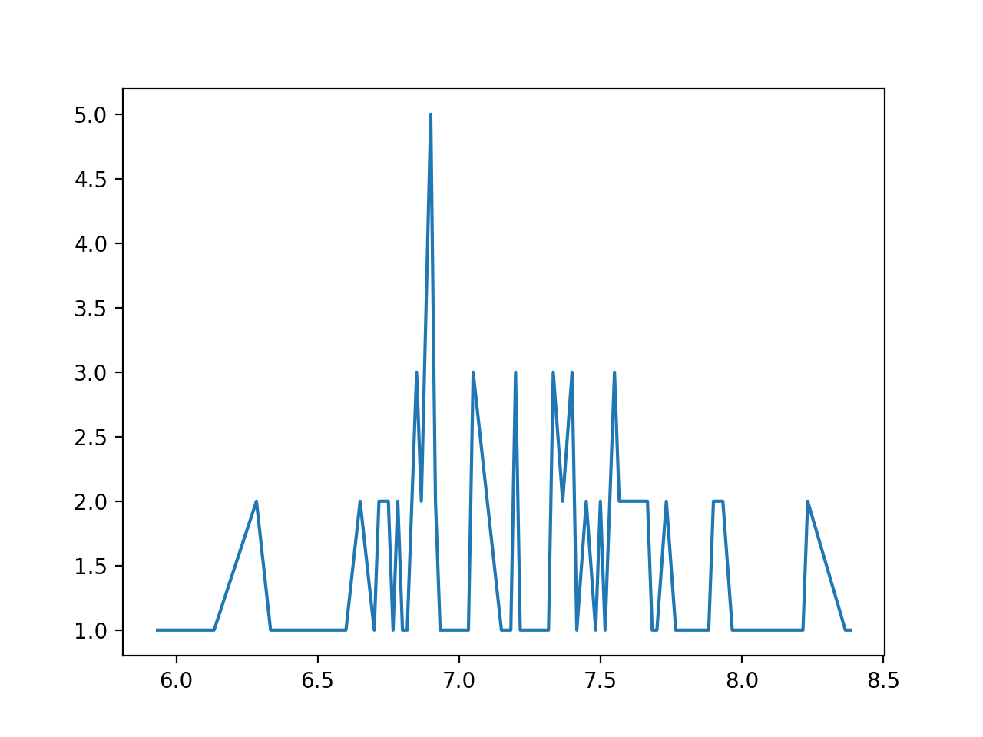

The x axis is the number of minutes it takes me to solve the cube, and the y axis represents how many times a certain times has appeared in the simulation. I thought this is a bit inaccurate, so I ran 10000 trials, which took about 1h30m…

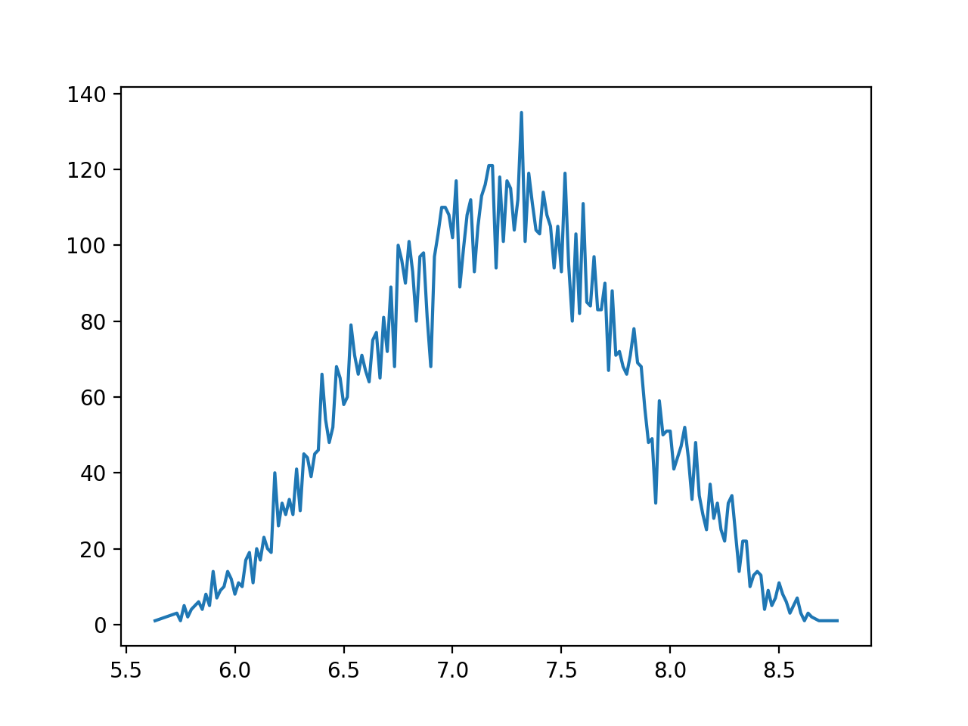

So the simulation shows that it would be most likely for me to get a 7.3 minute on 7x7.